**COAL**

**PROJECT**

**REPORT**

**Project Name:**

**PLAGIARISM CHECKER**

**Sec: C**

**Group Leader:**

**USAMA 19K-1463**

**Group members:**

**SAMEER 19K-1526**

**ALI MURTAZA 19K-1404**

**Supervision:**

**SIR SHOAIB RAUF**

**MISS NIMRA IQBAL**



**CONTENTS**

**BACKGROUND**

**01**

**SCREEN SHOTS OF OUTPUT OF PROGRAM**

**ALGORITHM**

**PROJECT OVERVIEW**

**04**

**03**

**02**

 

We want to do some challenging Task so we come

With an Idea of Plagiarism Checking.as there are many Cases of Cheating Observed in English Subjects as well as include subjects like Maths, Pakistan Studies and many more so we want to create a program which can resolve these issues by in time of seconds or which can help the teachers to easily check the plagiarism of students papers as well as it save`s the time of Teachers. Our Program is based on an Algorithm which is defined on next page.

**BACKGROUND**

**01**

**02**

So the steps to find the plagiarism is that first we

find the number of triplets in a given article then

we compare each triplet with second article and

count the frequency of same triplets if frequency

greater than 50 percent than it is cheated else not.

The Formula is: no of triplets = no of words – 2;

So this is an generalized formula which will show

Us that how many possible triplets can be create

From a file on based on the file`s data.

Than we make triplets and Every Triplet consist

Three words. After Making Triplets then we compare

The Triplets one by one with the data of Other Two Files.

Two article are taken as a input from file

and sent to triplet finder where triplets

are found and sent to search function to compare triplet of file1 with file2 and count frequency of comparison after whole file is compared by all possible Triplets with the data of File2 and File3 than the percentage is counted and it will print the percentage of Plagiarism on console than if it is greater than 50 then the article is cheated else not.

**PROJECT OVERVIEW**

**ALGORITHM**



**03**

**SCREEN SHOTS OF OUTPUT OF PROGRAM**

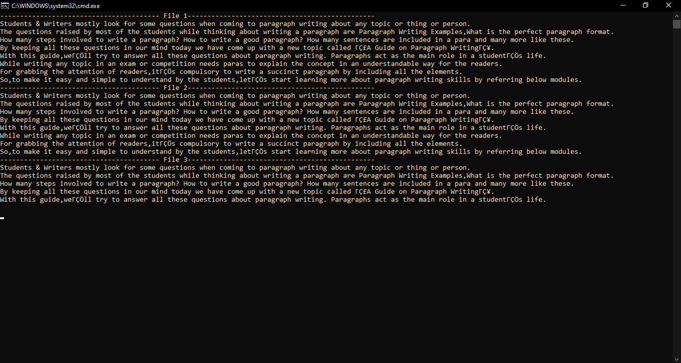



**04**

